DNF

实验1 2020.3.24
Realnvp block=10 hidden=512 input=120 cond_dim=120 var=1 & 1k

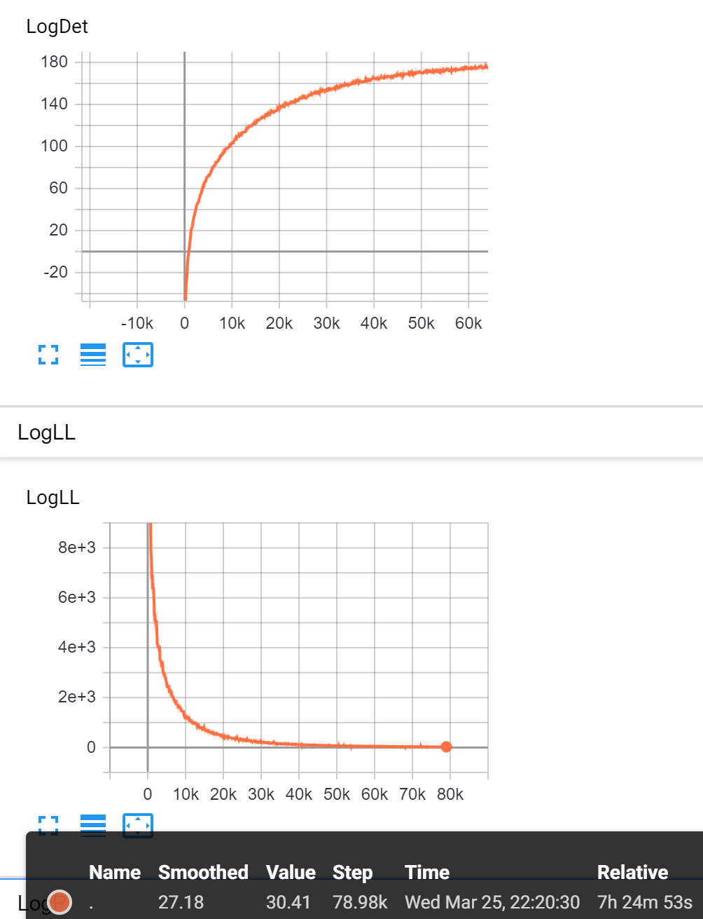
训练集在隐空间高斯性
skew = 0.0031436711142305285 kurt = -1.1428269232454675
测试集在隐空间高斯性
wsj+ce:
skew = 0.02316198189194741 kurt = -0.7585778409715496
wsj+ce+je:
skew = 0.02062119066443605 kurt = -0.8155078098045876
训练集可视化：
直接取两维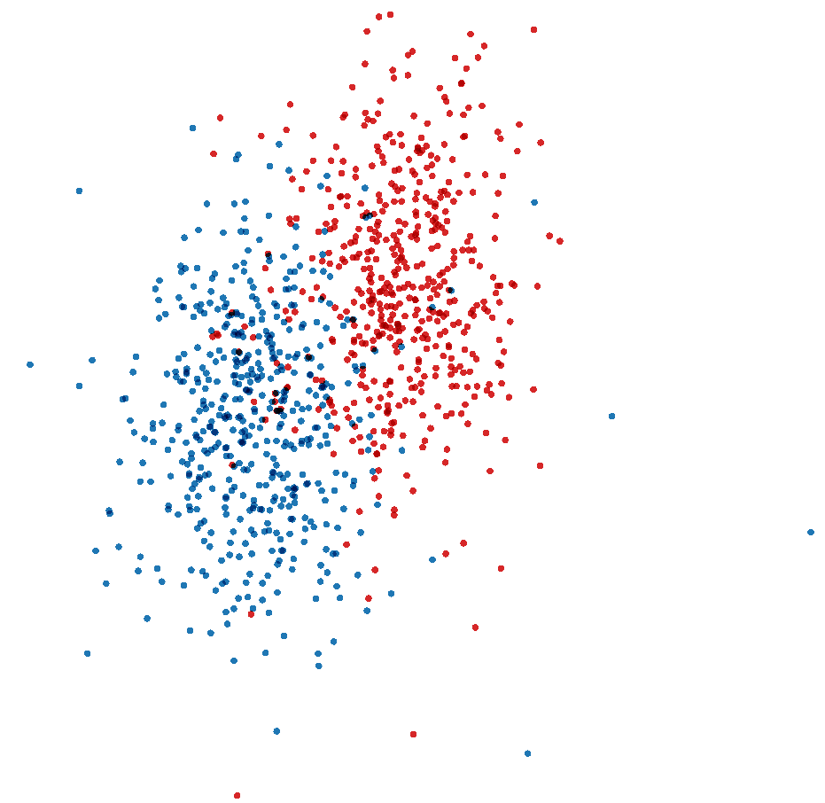
T-sne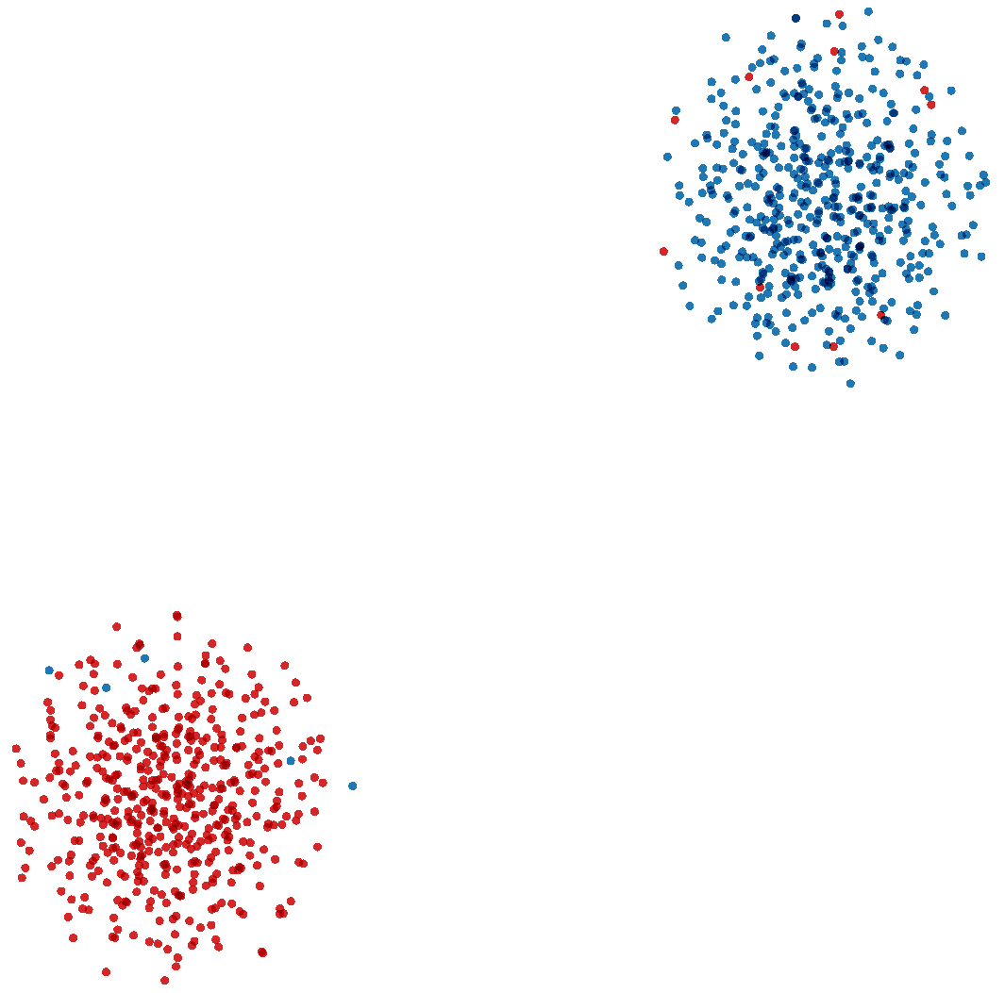

测试集可视化：
用纯英语和中国英语（取自训练集外的同数据集）
两维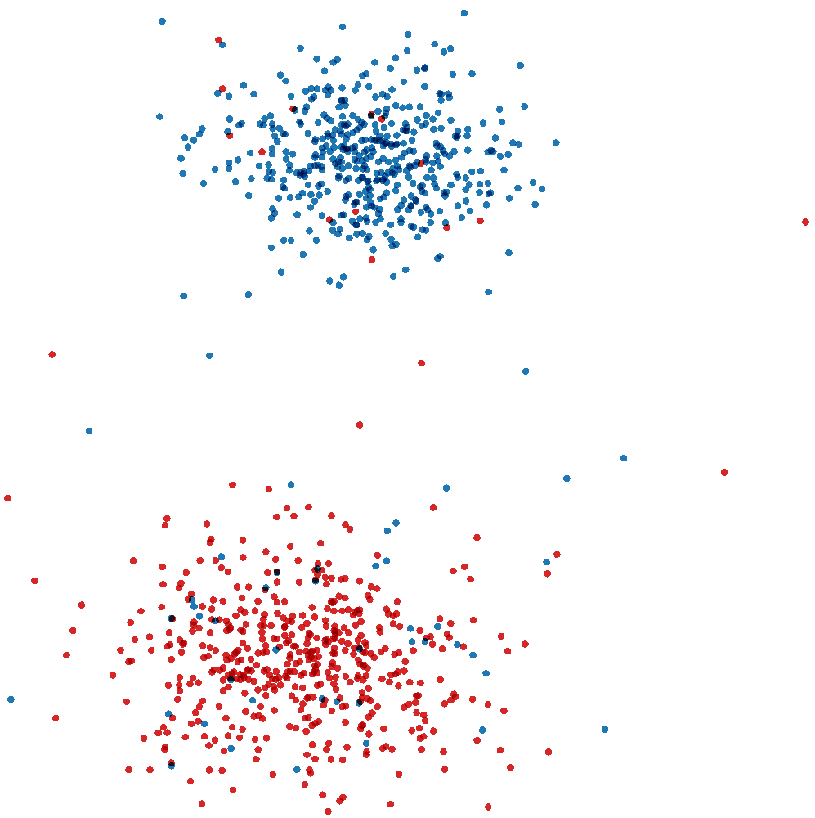
T-sne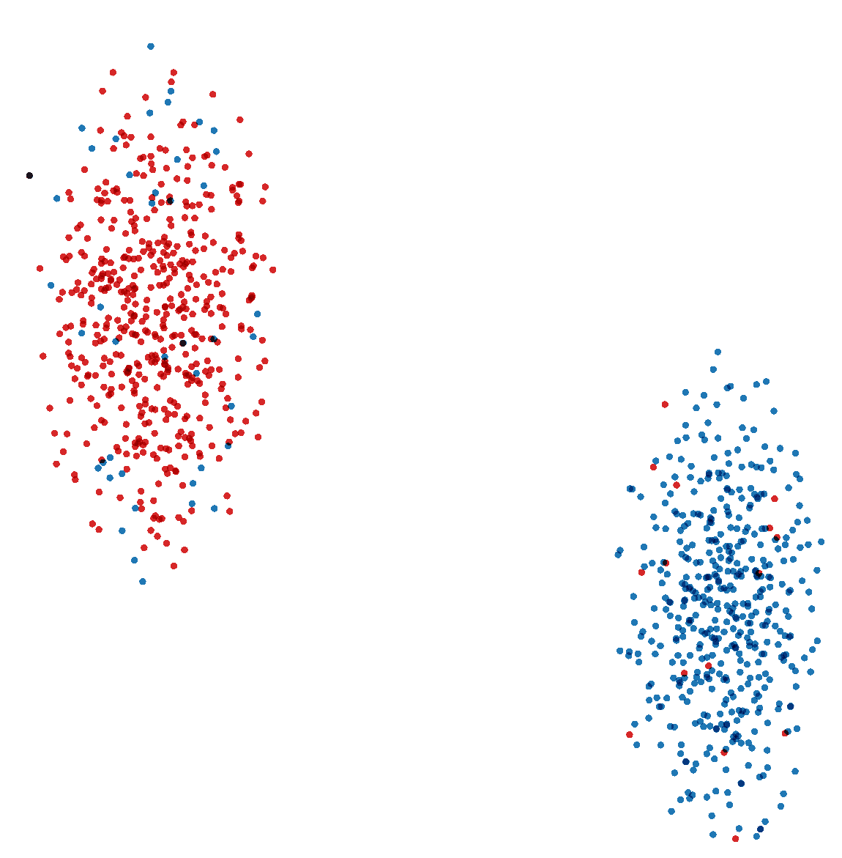

使用纯英语、中国英语、日本英语； 蓝色wsj，红色ce，粉色je
两维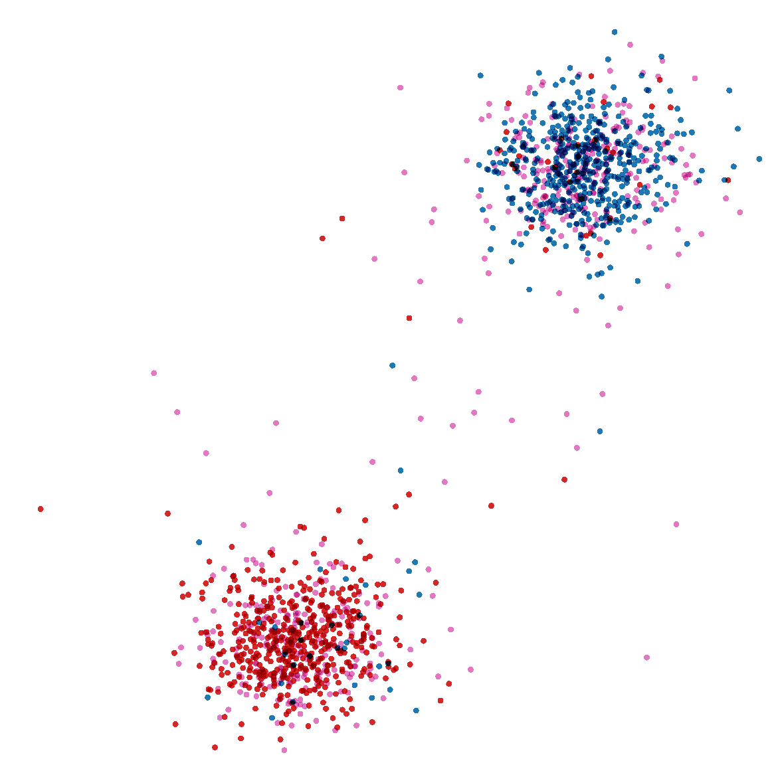
t-sne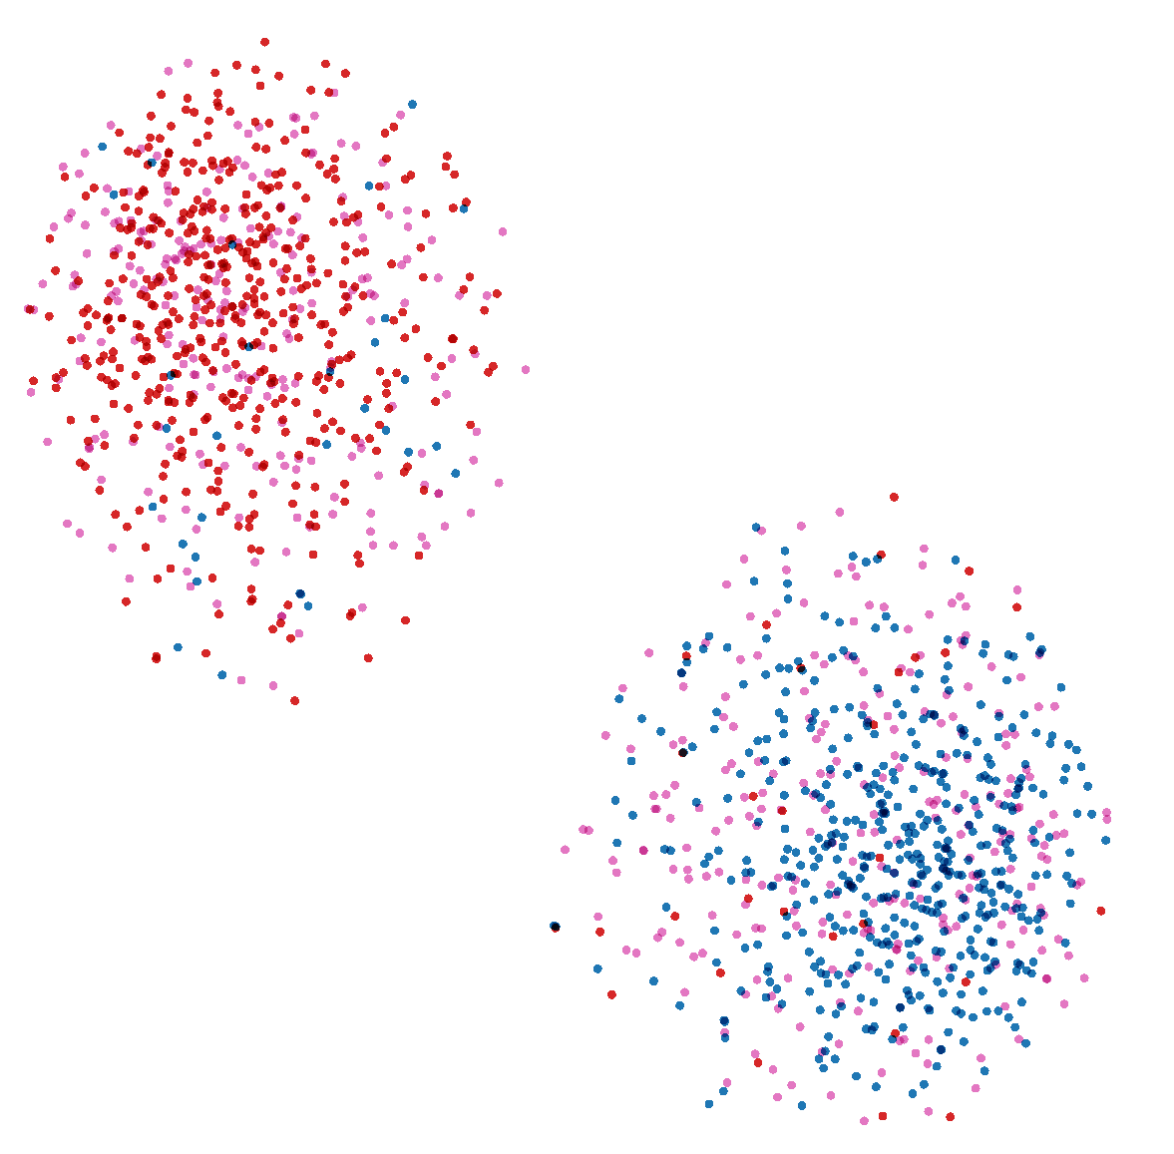
可视化结果表明，模型对于集内（wsj和ce）区分性较好
实验2 2020.3.25
Realnvp block=10 hidden=512 input=440 cond_dim=400 var=1 & 1k
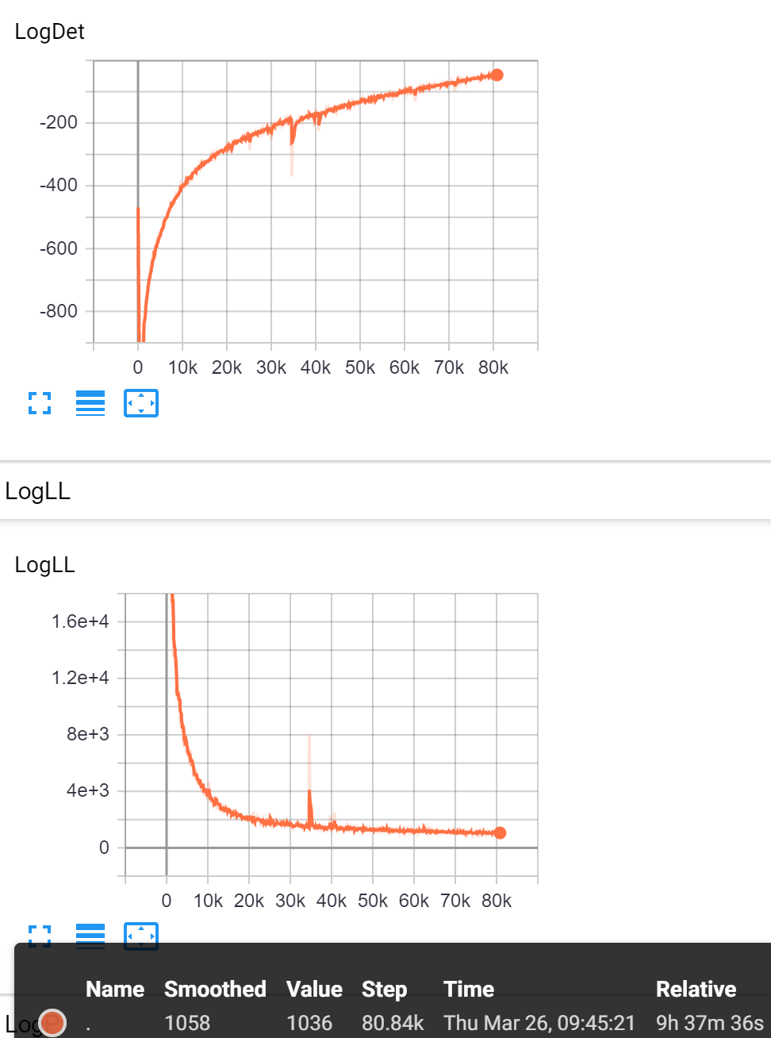
有一个明显的、奇怪的波动。

训练集在隐空间高斯性：
c(dim=400): skew = 0.0006283868383616209 kurt = -1.5424493272780615
r(dim=40): skew = 0.008583634172100573 kurt = 0.7271008120156788

测试集在隐空间高斯性：
wsj+ce:
c(dim=400): skew = 0.0001360115630782843 kurt = -1.6097791542651472
r(dim=40): skew = 0.0037121913279406725 kurt = 0.7380078159736696
wsj+ce+je:
c(dim=400): skew = 7.981912058312446e-05 kurt = -1.5953344626309138
r(dim=40): skew = 0.00020940345712006092 kurt = 0.7430761053304892
训练集分布
两维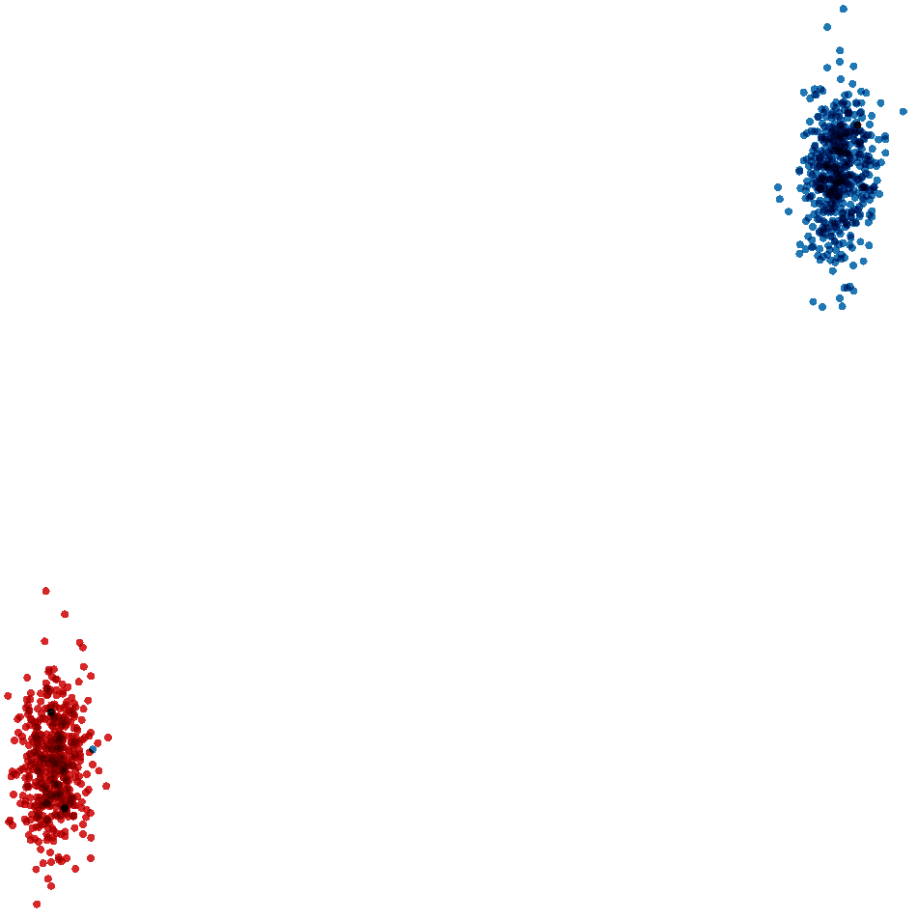
T-sne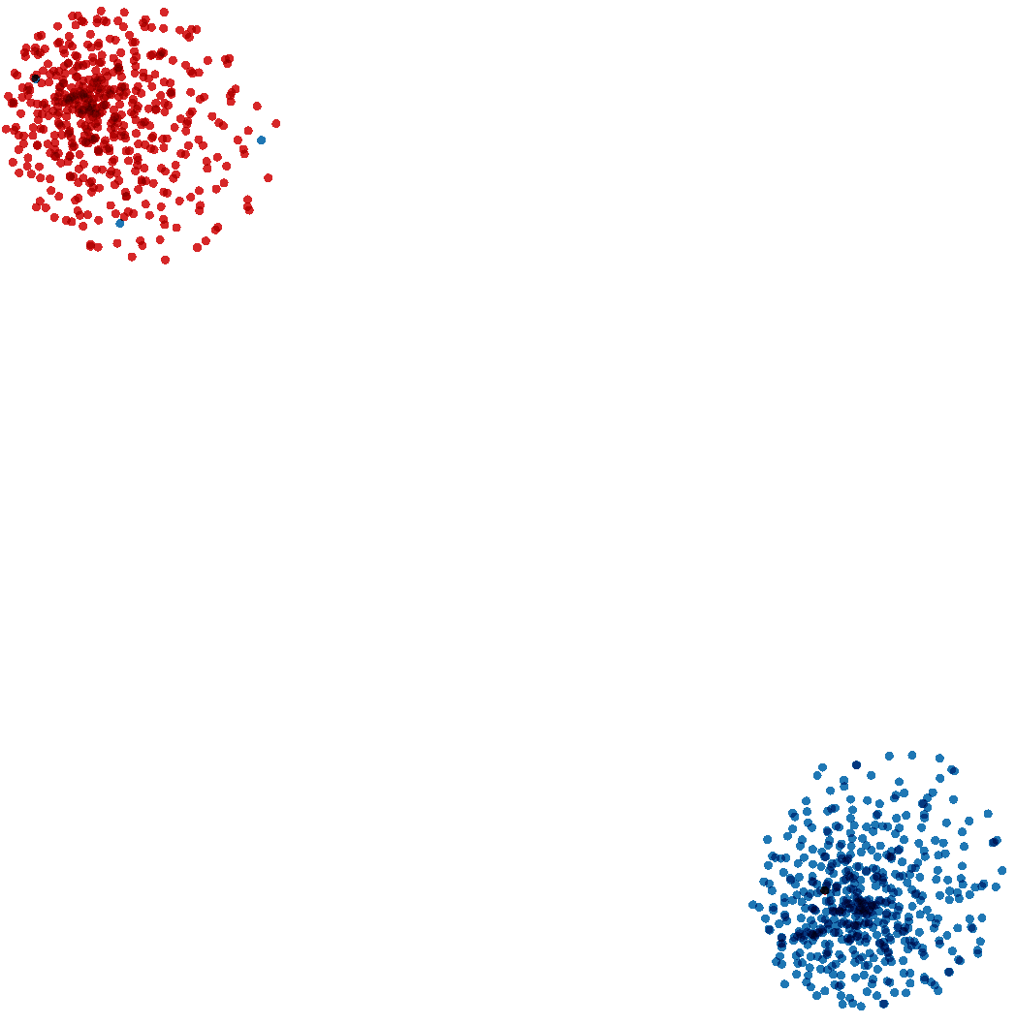
测试集分布
wsj+ce
两维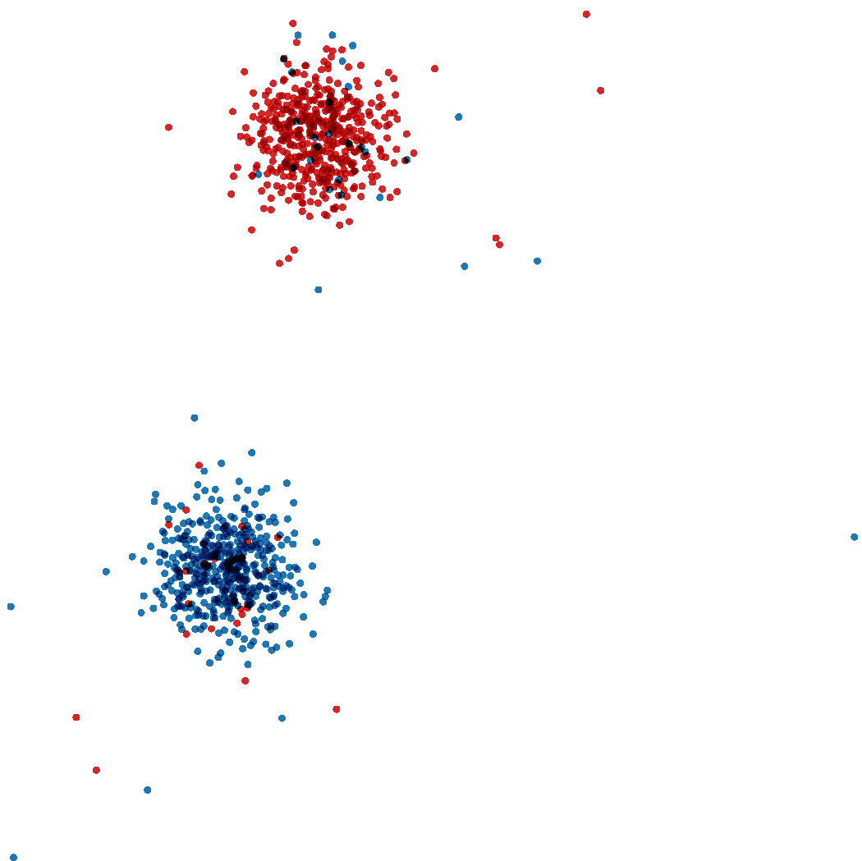
t-sne 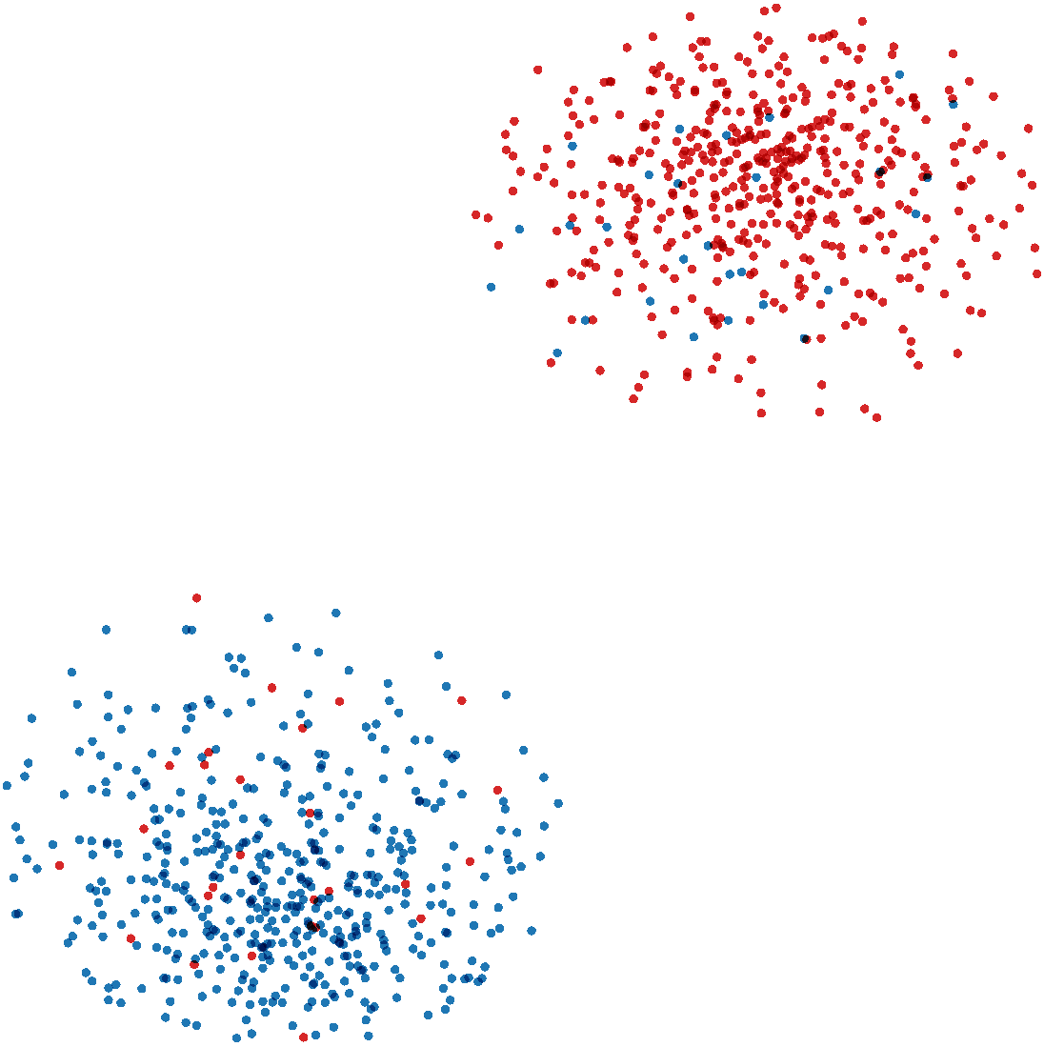
wsj+ce+je (wsj&ce来自同集）蓝色wsj，红色ce，粉色je
两维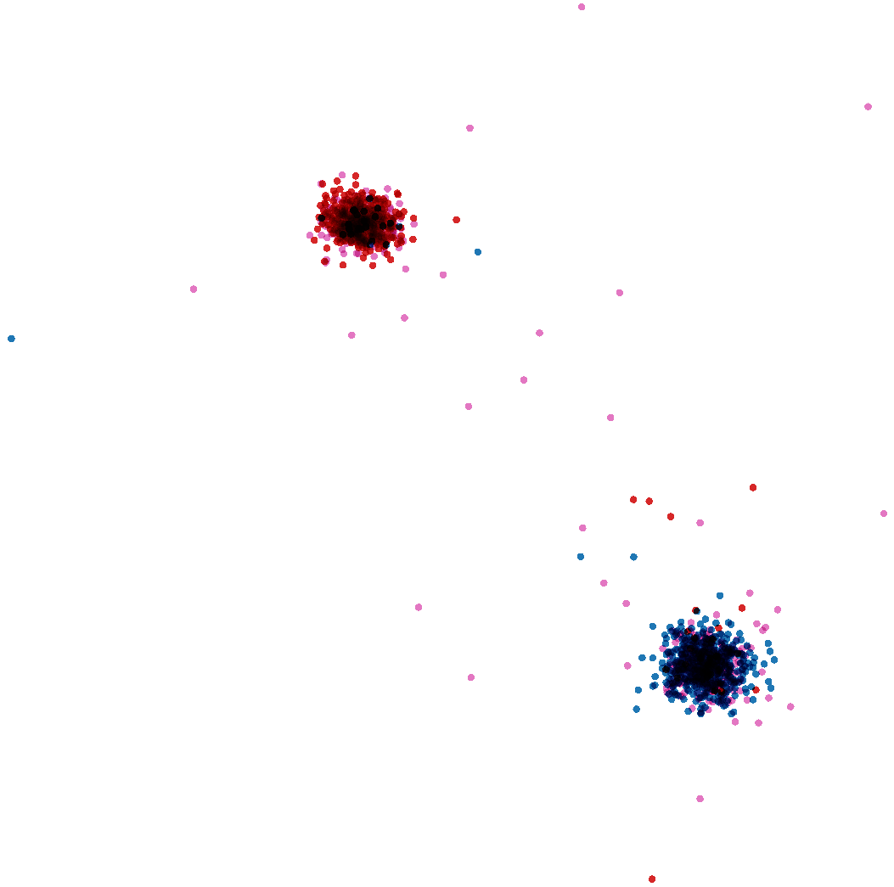
t-sne 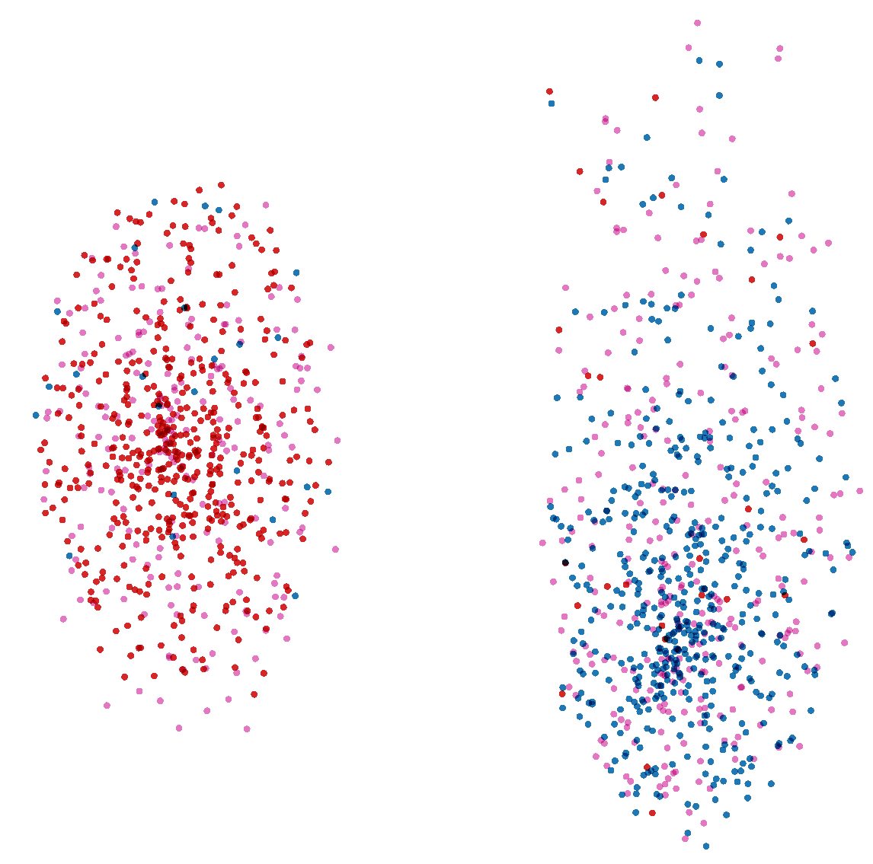
实验3 2020.3.25
Realnvp block=10 hidden=512 input=440 cond_dim=440 var=1 & 1k
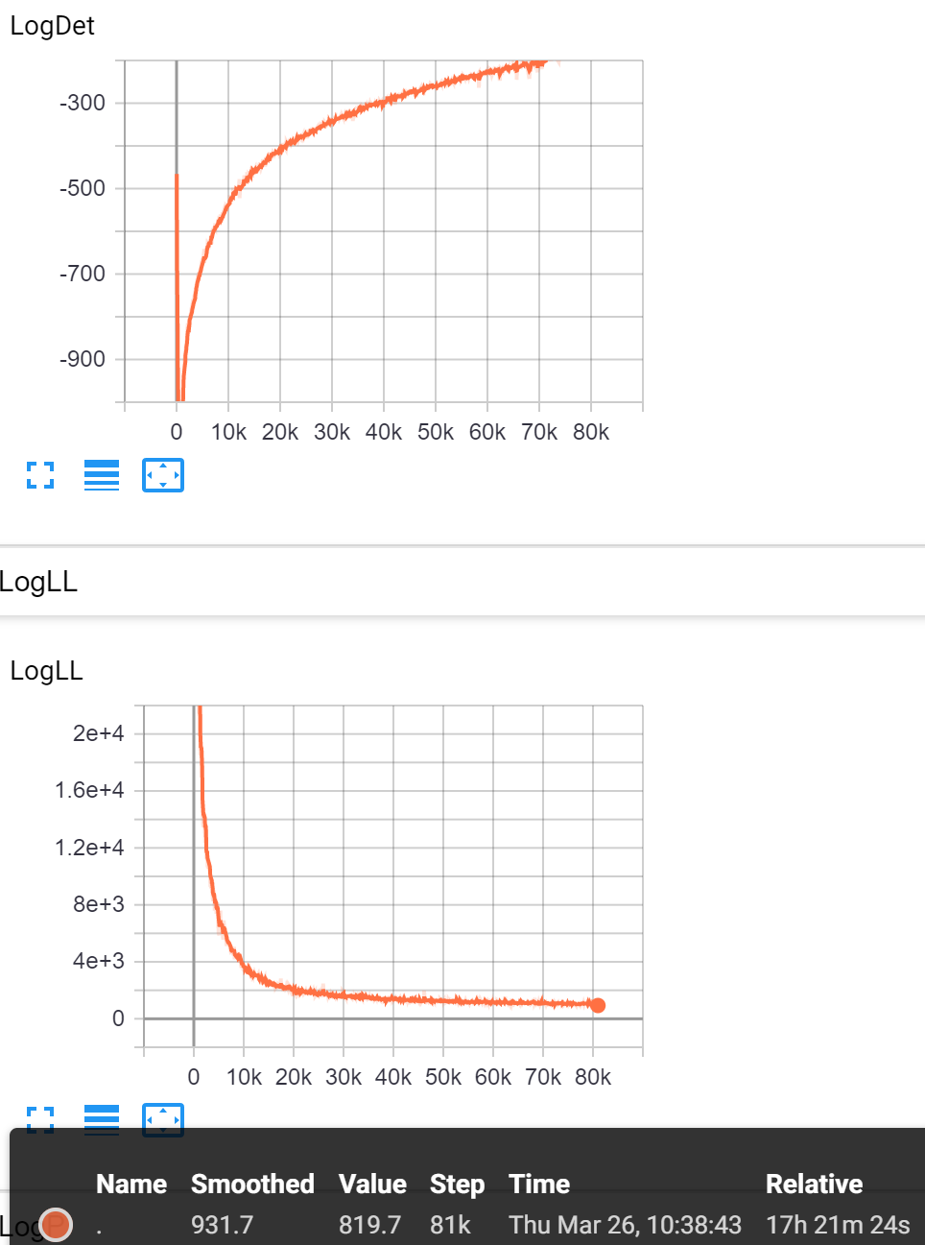
同样的数据，这次没有出现奇怪的波动。

训练集在隐空间高斯性：
c(dim=440): skew = -0.014642360260371457 kurt = -1.4761772624802512
测试集在隐空间高斯性：
wsj+ce两分类：
c(dim=440): skew = -0.005829388468092392 kurt = -1.5395667708074203
wsj+ce+je三分类:
c(dim=440): skew = -0.005821182986123445 kurt = -1.5287577271416113
训练集分布：
两维
t-sne

测试集分布：
Wsj+ce：
两维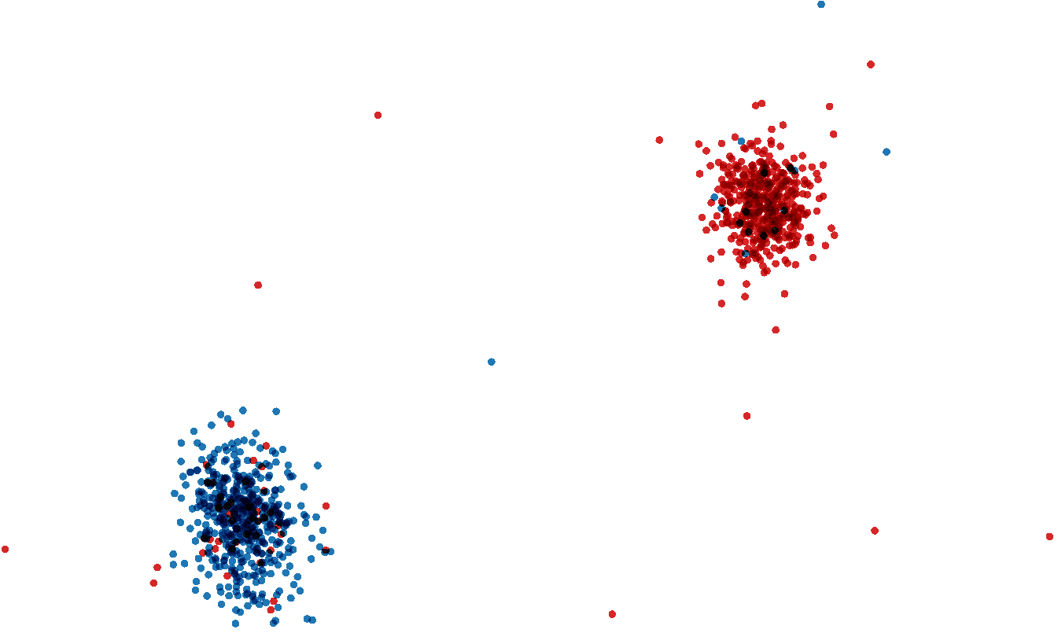
t-sne 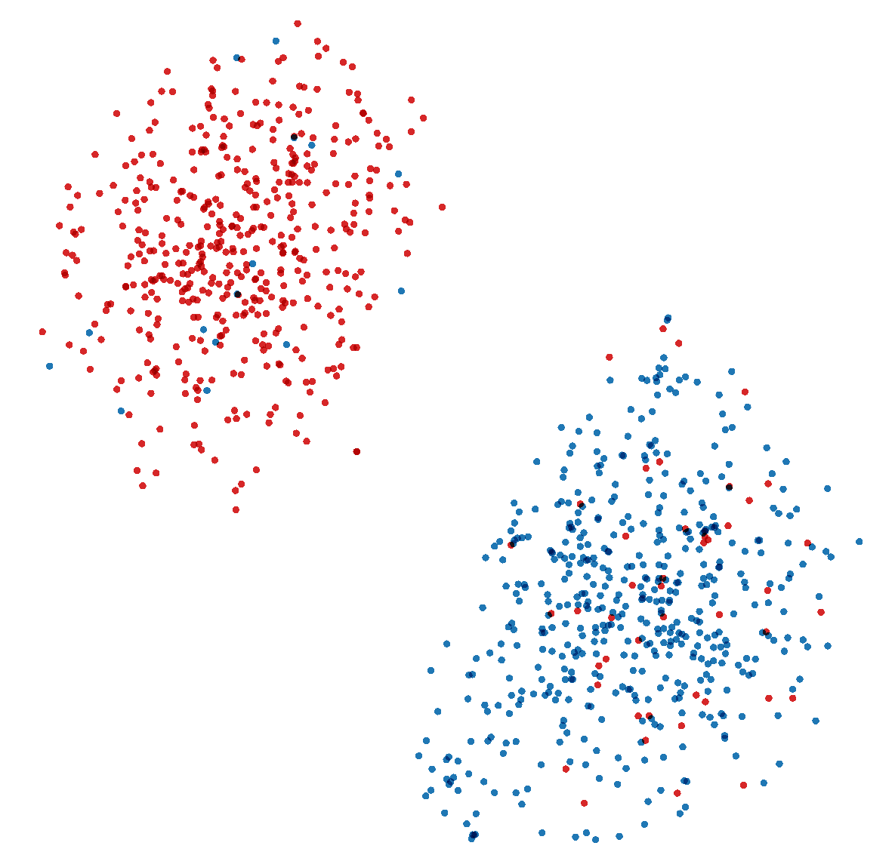

wsj+ce+je；蓝色wsj，红色ce，粉色je
两维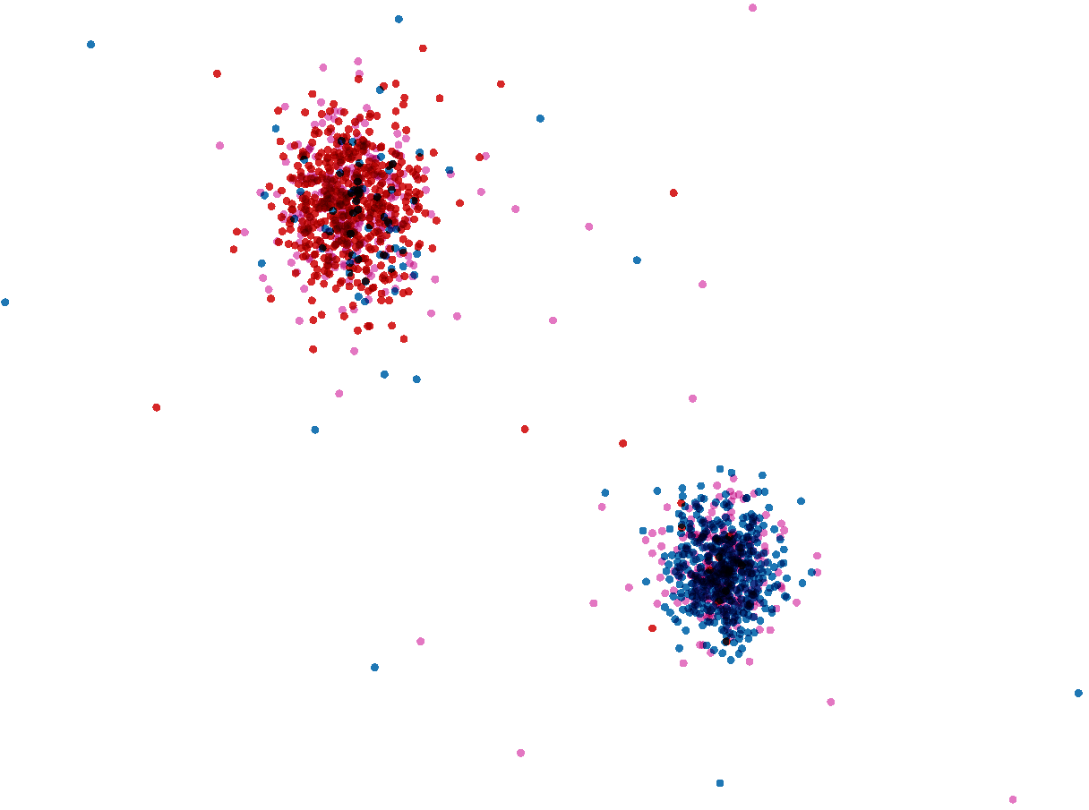
t-sne 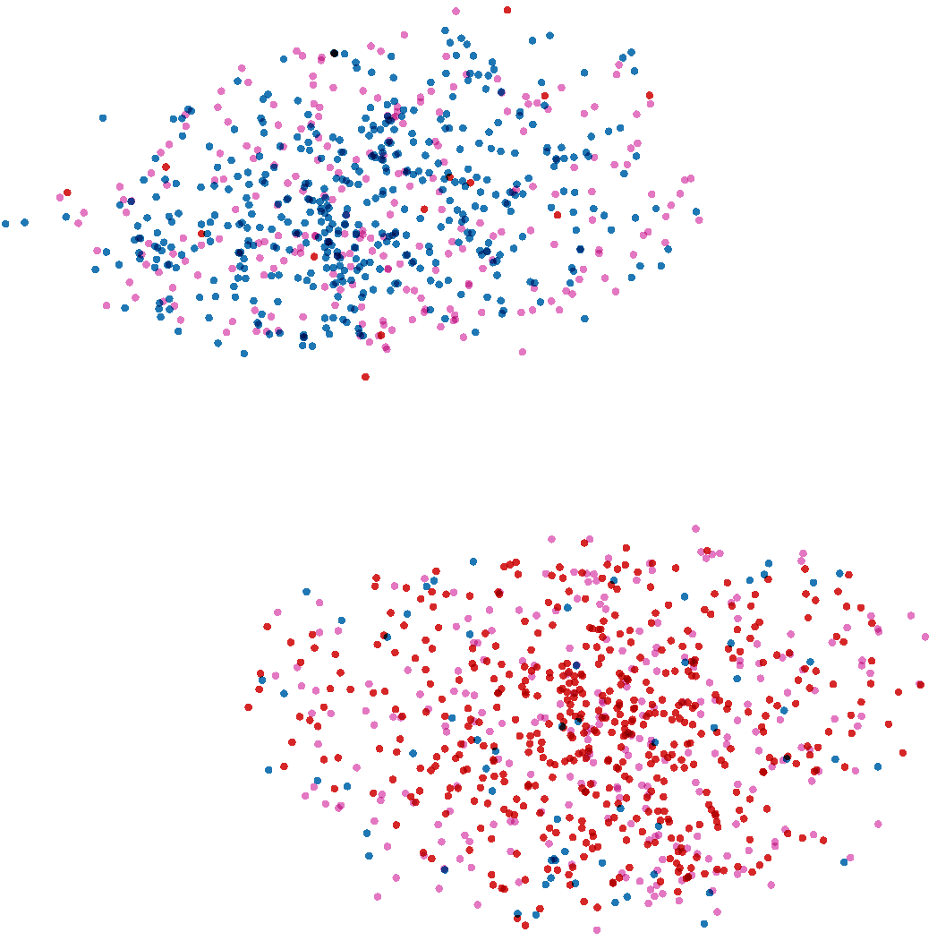
实验1、2、3说明，在可视化的层面上，对于wsj和ce分类性较好。
对于没见过的je，依然不会分布到极其外围的位置，说明可能学到了英文发音的信息。

Normal flow model

用wsj-50h中的9/10训练
--epochs 100 --batch-size 10000 --lr 0.0001 --num-blocks 10
real_nvp / relu / num_hidden = 256
以下test均用epoch=95的model
- 训练结果：
LogLL (loss) = -41.869190 LogP = -170.205643 LogDet = 212.074829
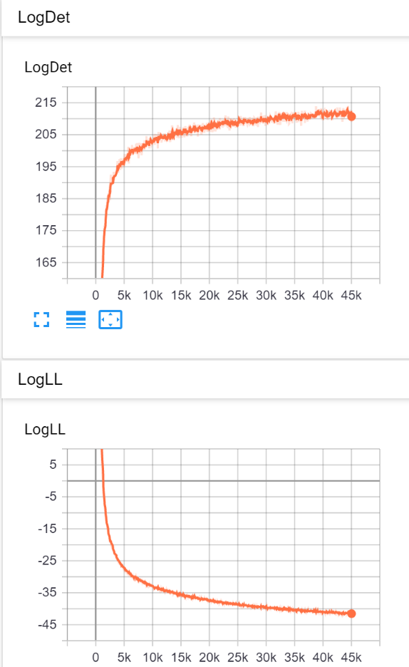
- 训练集（约45h）在latent空间：
LogLL = 1479.559040 LogP = -1443.457739 LogDet = -36.101301
456万帧，120维
- wsj-50h训练集外的1/10（约5h）在latent空间：
LogLL = 1466.184247 LogP = -1429.757313 LogDet = -36.426934
46万帧，120维
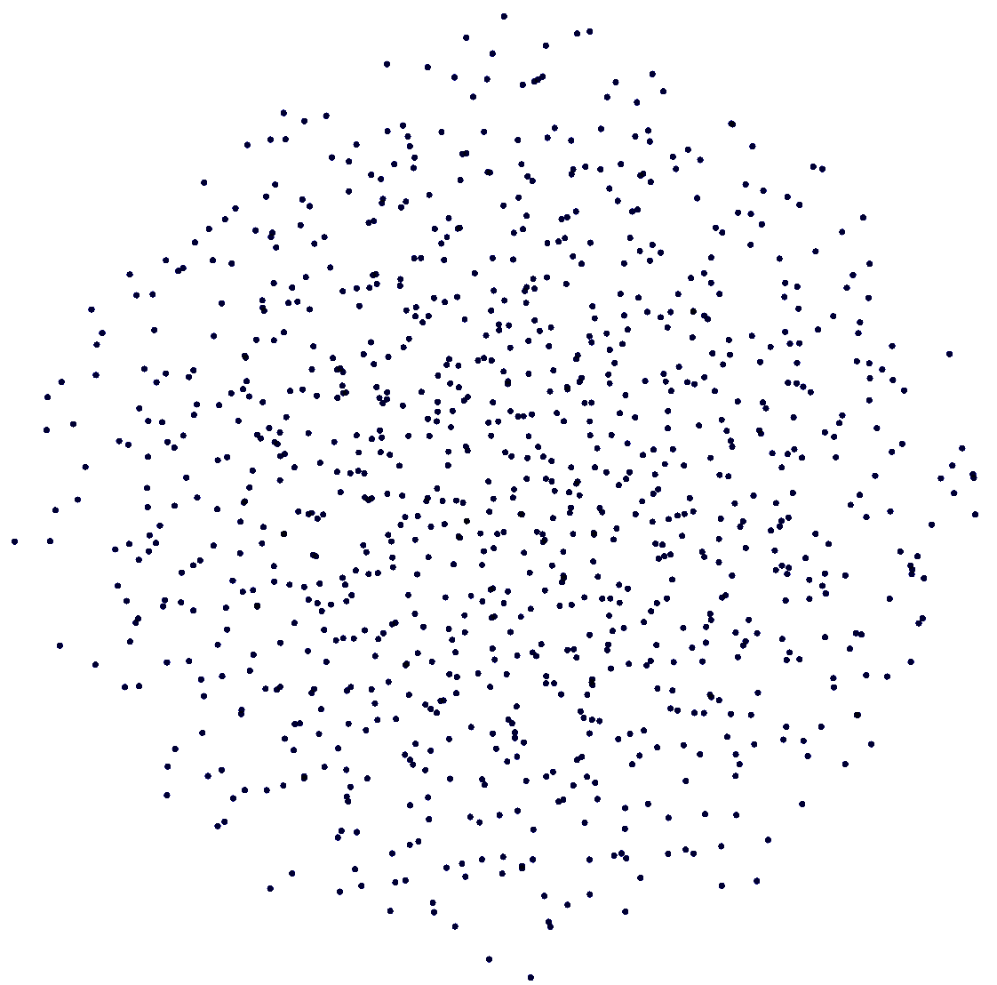
- L2（Chinglish集，约30h）在latent空间：
LogLL = 1655.813159 LogP = -1601.595372 LogDet = -54.217786
422万帧，120维
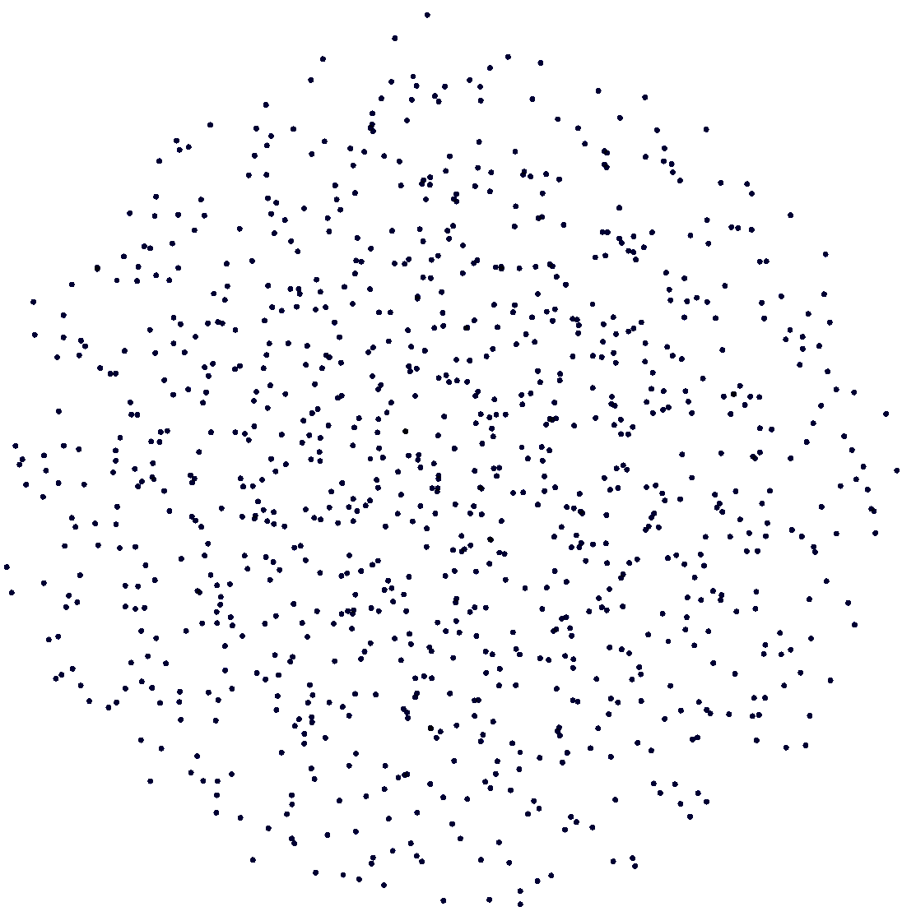
- JE (Japanese English, about 2h. Include score 1~5)
LogLL = 1573.815700 LogP = -1529.885478 LogDet = -43.930221
20万帧，120维
- JE(Score 1&2)
LogLL = 1568.640994 LogP = -1525.555617 LogDet = -43.085376
75000帧，120维
- wsj-test ce je(1&2)在latent空间中分布
