Here is the frequency spectrum of the 5 vowels ‘a o e i u v’:
‘a’:
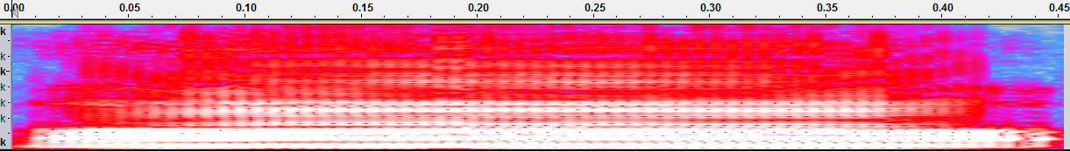

‘o’:
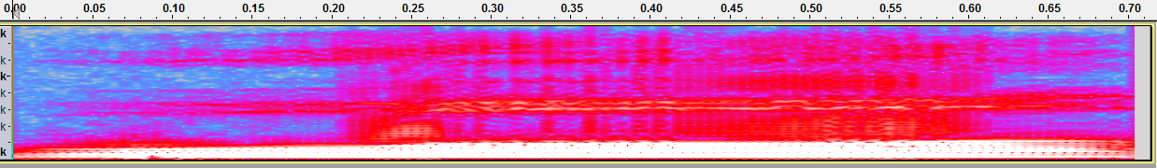

‘e’:
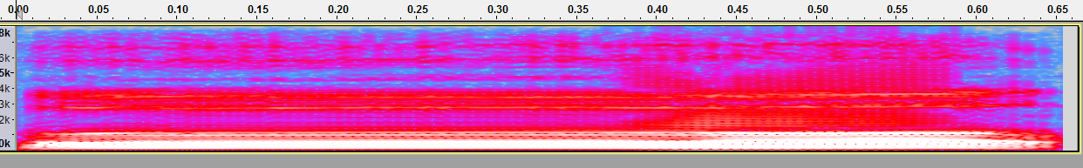

‘i’:
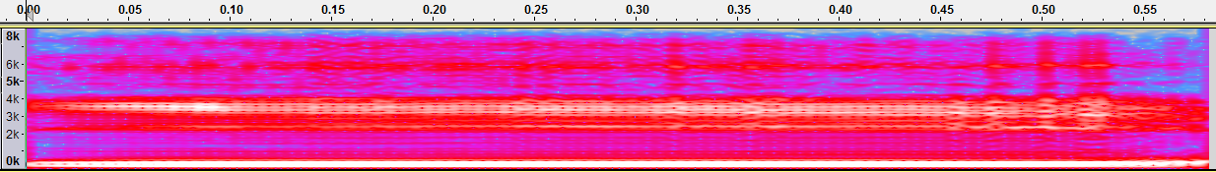

‘u’:
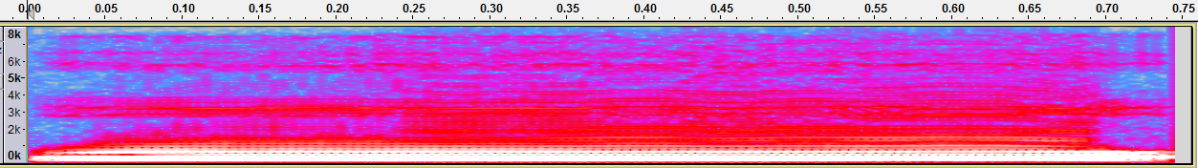

‘v’:
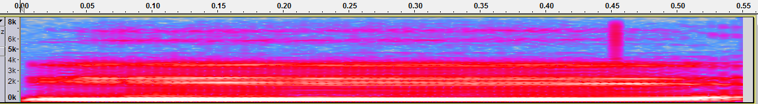

Here is the figure of the 5 vowels using t-SNE:

Input:40-dim
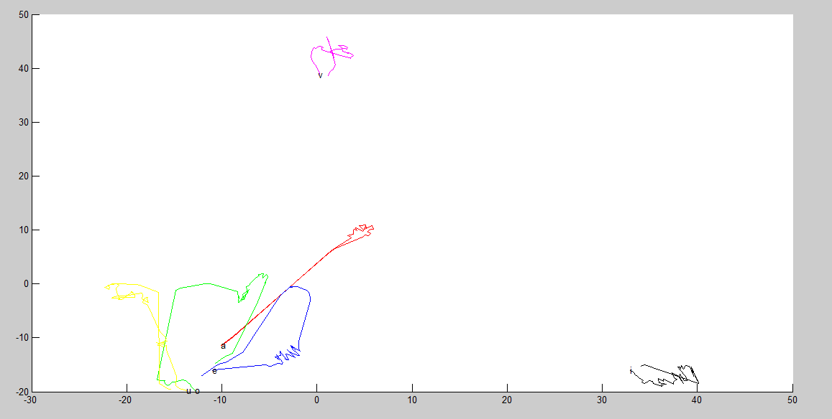

First-layer:40-dim
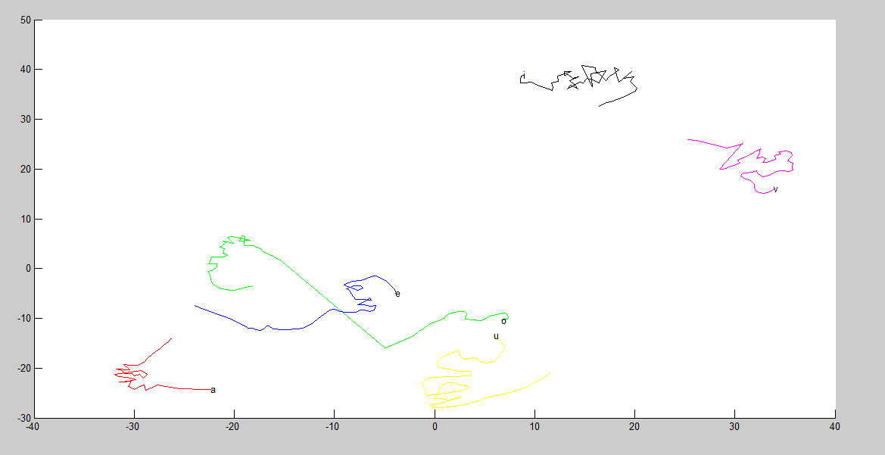

Second-layer:40-dim
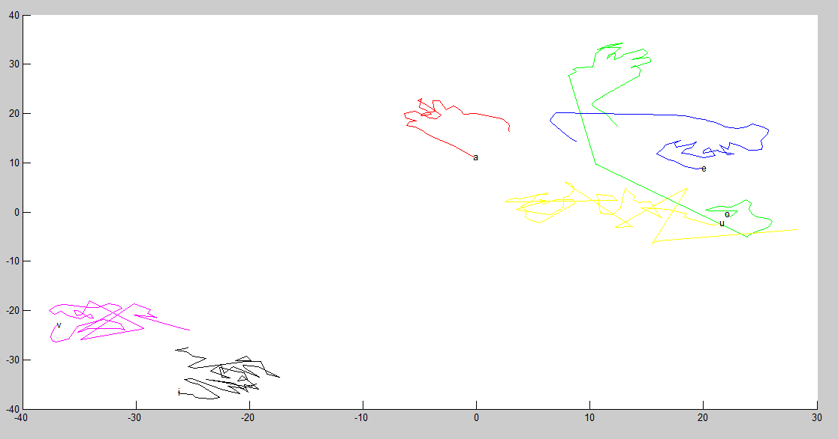

Third-layer:40-dim
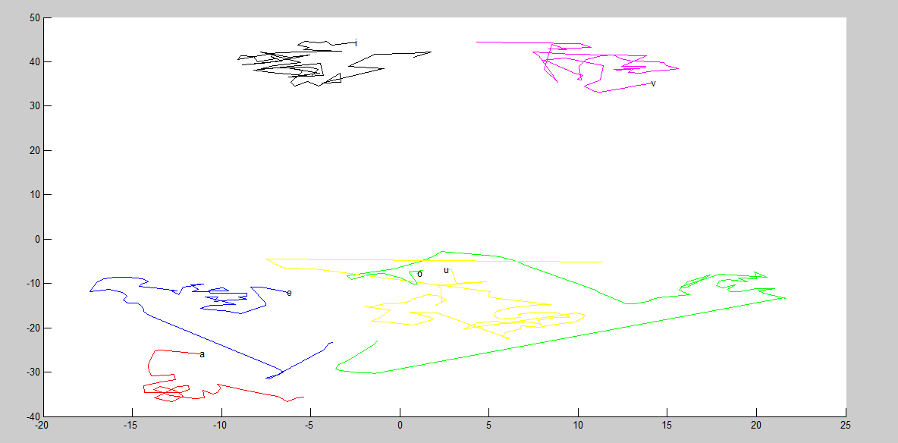

Forth-layer:40-dim
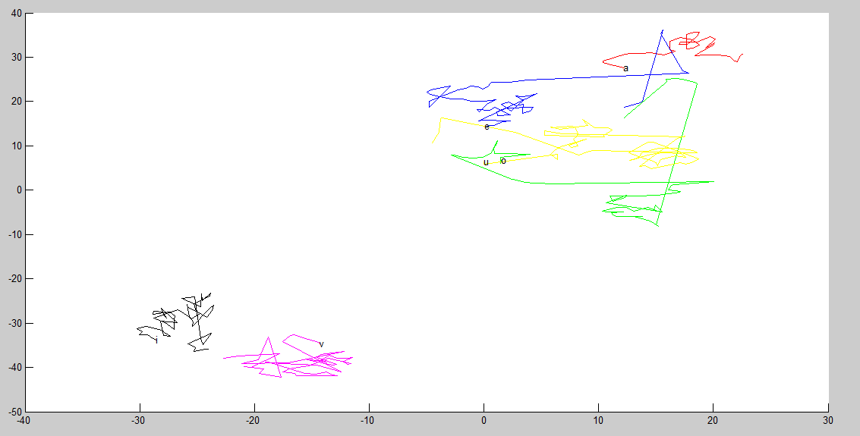

Output:478-dim


