Frequency spectrum:
Clean:
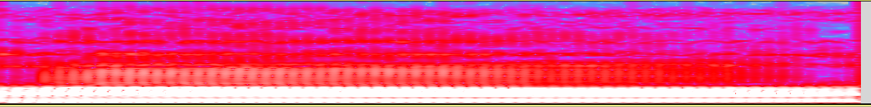
Noise-level:(up to down, the smaller the noisier)10, 7, 5, 4, 3, 1.5, 0.1, 0.01, 0.0001
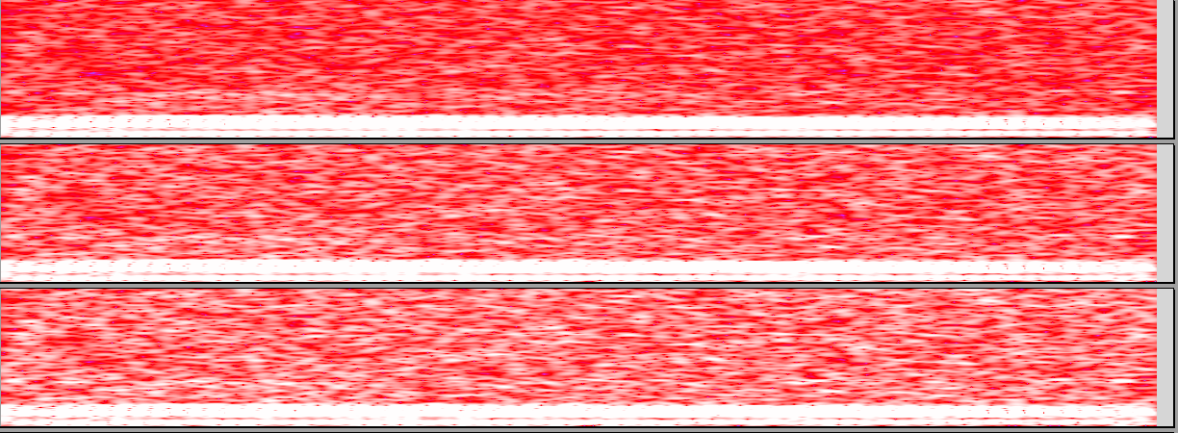
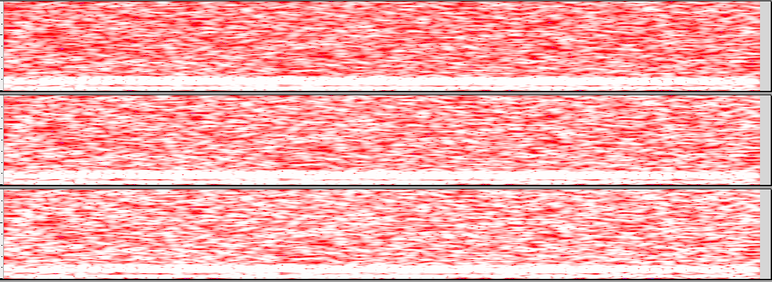
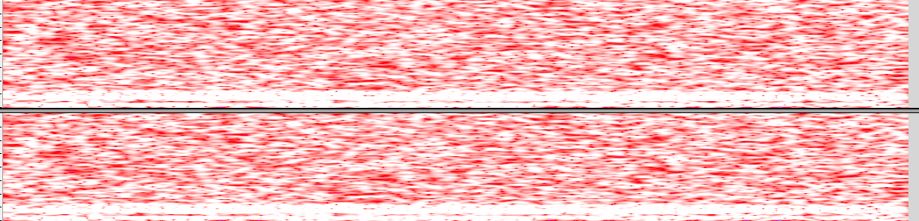

The output-layer of each level of noise:
Clean
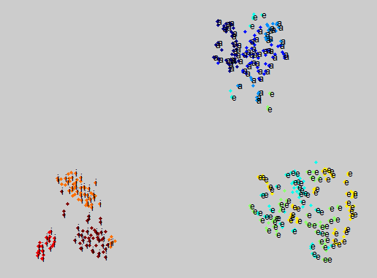

Noise-level=10
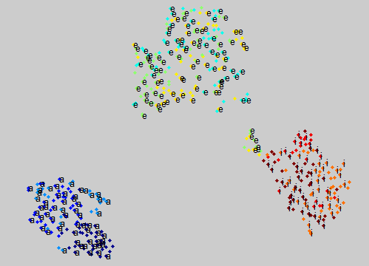

Noise-level=7
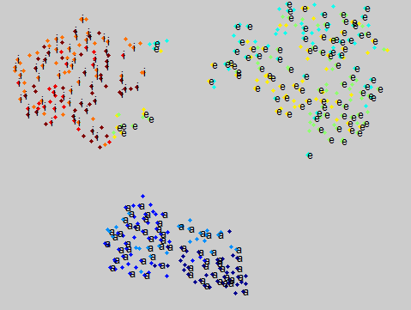

Noise-level=5
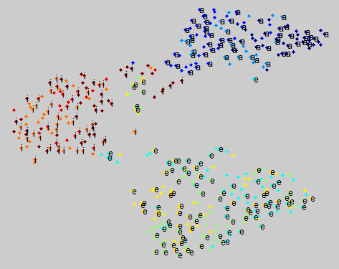

Noise-level=4
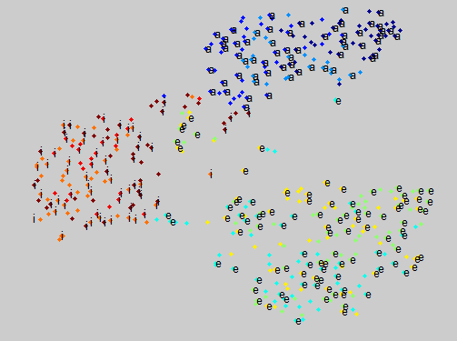

Noise-level=3
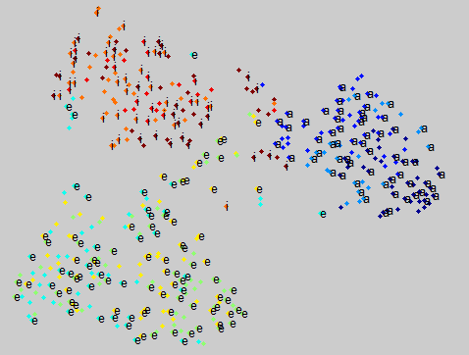

Noise-level=1.5
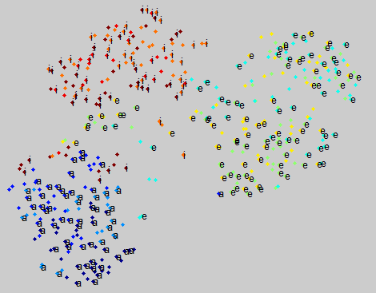

Noise-level=0.1
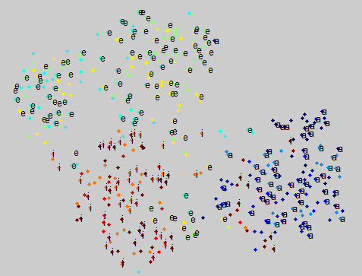

Noise-level=0.01
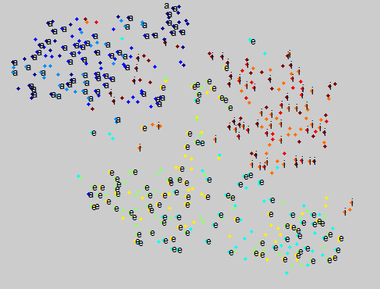

Noise-level=0.0001
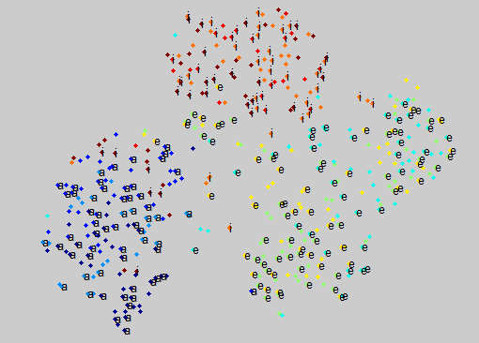

As can be seen from the spectrum, if the noise level is smaller again, the spectrum will not be changed so much, as well as the figures.At the same time, the figures show that the points are merged little by little.

