Frequency spectrum:
Clean:
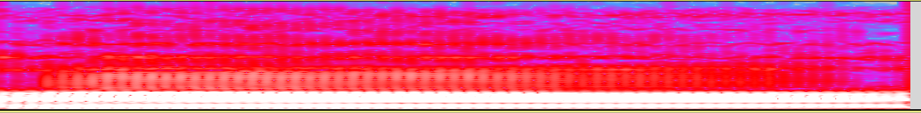
Noise-level:(up to down, the smaller the noisier)10, 7, 5, 4, 3, 1.5, 0.1, 0.01, 0.0001
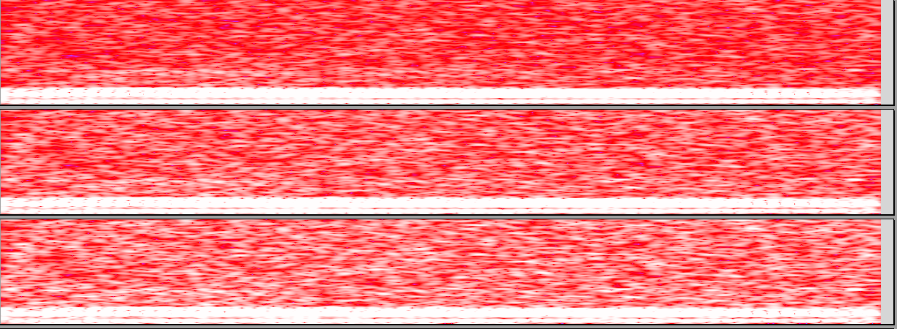
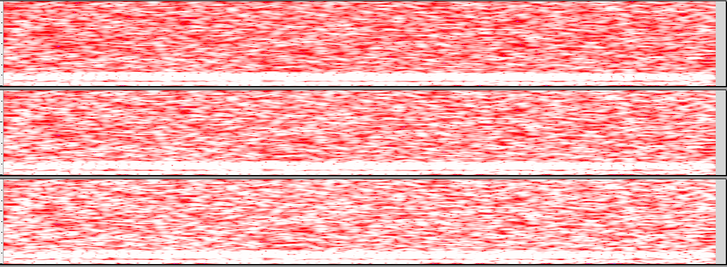
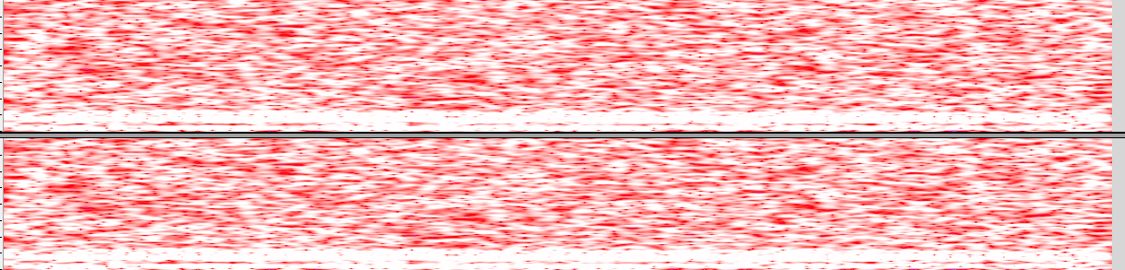

The output-layer of each level of noise:
Clean
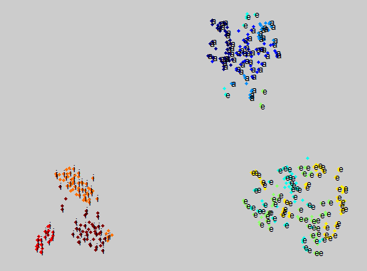

Noise-level=10
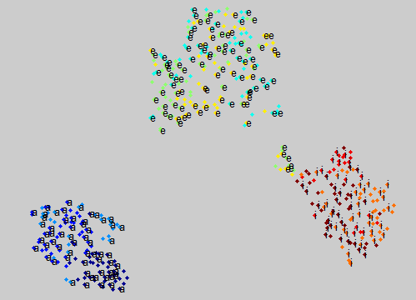

Noise-level=7
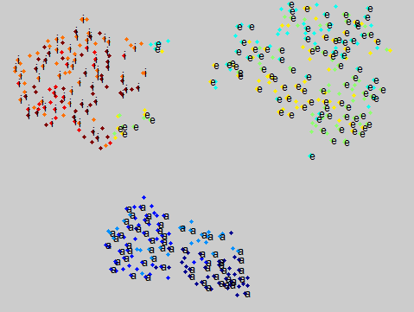

Noise-level=5
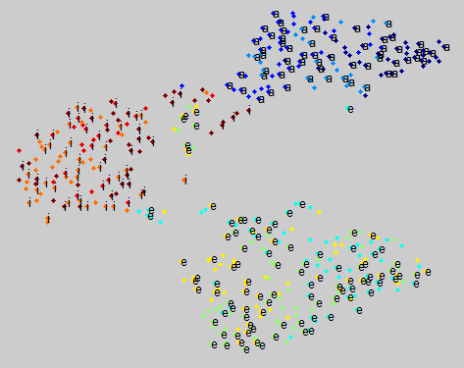

Noise-level=4
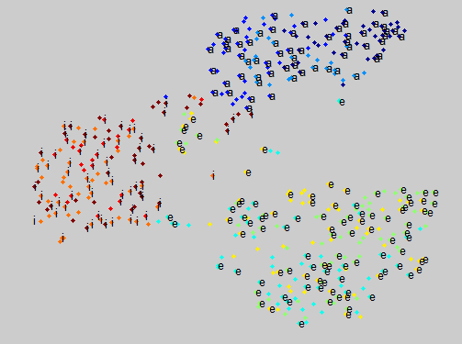

Noise-level=3
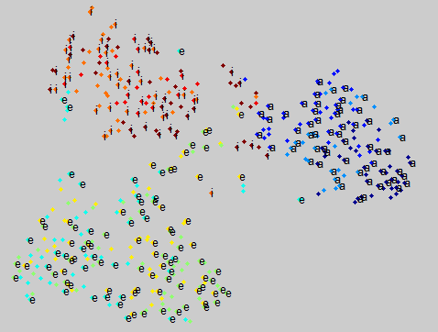

Noise-level=1.5
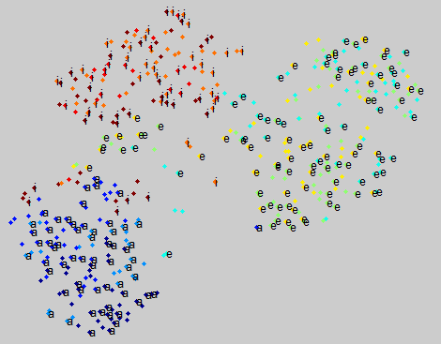

Noise-level=0.1
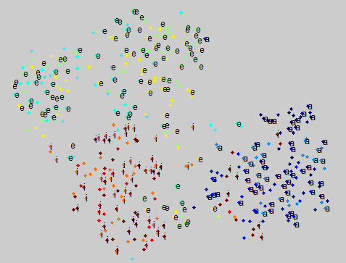

Noise-level=0.01
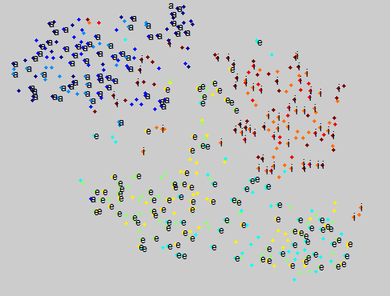

Noise-level=0.0001


